1.2 Changes of states
Name: ____________________ Class: ____________________ Due date: 9.10
1. Which change of state takes place during evaporation? （ ）
A gas to liquid B liquid to gas C liquid to solid D solid to gas

2. Diagrams X, Y and Z represent the three states of matter.
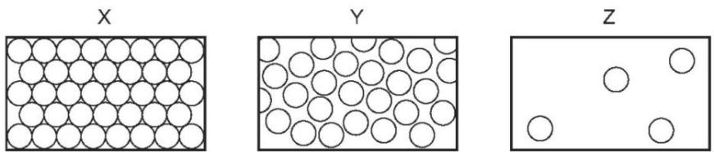
Which change occurs during boiling? （ ）
A X to Y B Y to Z C Z to X D Z to Y

4.When a substance is heated from a solid to a liquid and then to a gas, the energy is mainly used to （ ）
A. Increase the kinetic energy of the particles B. Break the attraction forces
C. Change the color of the substance D. Increase the mass of the substance

5.When a liquid is cooled, its particles （ ）
A. Move faster B. Move slower C. Spread out more D. Become larger

6. What are the processes W, X, Y and Z in the following diagram? （ ）
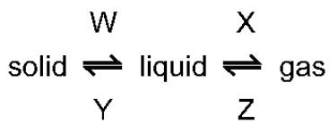
 | W | X | Y | Z
A | condensing | boiling | freezing | melting
B | condensing | freezing | melting | boiling
C | melting | boiling | freezing | condensing
D | melting | freezing | condensing | boiling

7. The particles of a substance gain energy and change from a regular ordered structure to a disordered structure with large distances between the particles.
Which change of state is described? （ ）
A boiling B evaporation C melting D sublimation

8.The three rectangles show the arrangements of the particles in each of the three states of matter X, Y and Z represent the processes needed to change from one state to another.
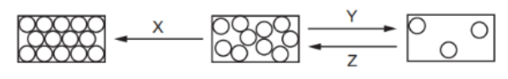
What are the processes X, Y and Z? （ ）
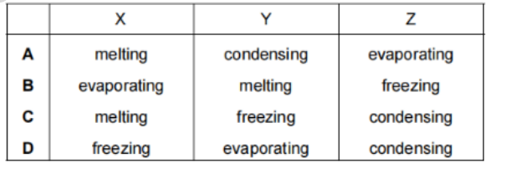

9 .The diagram shows the arrangement of particles in the three states of matter.
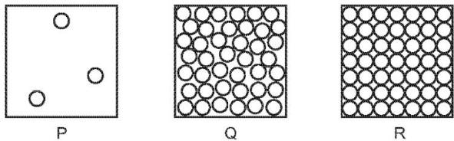
Solid carbon dioxide (dry ice) sublimes to gaseous carbon dioxide.
Which row describes the initial and final states? （ ）
 | initial state | final state
A | P | R
B | Q | P
C | R | P
D | R | Q

10.What is the difference between evaporation and boiling?

11.Describe what happens to the particles of a substance during the process of condensation.

